

**The Eventor**

**By**

Seif El-Deen Negm

Mariam Mohamed Abdelhamid

Haneen Mohamed

Nadeen Ahmed

A Graduation Project Report Submitted to   
the AAST’s College of Computing and Information Technology  
in Partial Fulfillment of the Requirements for

the Degree of Bachelor of Science in Computer Science.

July, 2022, Alexandria, Egypt.

**Supervised By**

Dr. Saleh Mesbah

**&**

Dr.Walid Rabie

**ABSTRACT**

**The Eventor**

**By**

Seif El-Deen Amr Negm

Haneen Mohamed

Mariam Mohamed

Nadeen Ahmed

The Eventor is an event planning and management website, The Eventor helps users to organize events from one place. The website’s idea is to offer customers a wide range of options with different price ranges and ratings, so that they can compare between vendors and decide which is the best choice for them. Moreover, it gives the vendors a place where they expand their borders, and let their work be more exposed and seen.

**Date submitted:**

5th of July 2022

**SIGNATURE PAGE**

The Eventor

**By**

Seif El-Deen Negm

Mariam Mohamed

Haneen Mohamed

Nadeen Ahmed

A Graduation Project Report Submitted to   
the AAST’s College of Computing and Information Technology  
in Partial Fulfillment of the Requirements for

the Degree of Bachelor of Science in Computer Science.

July, 2022, Alexandria, Egypt.

Approved: advisor’s name, title

Signature: ___________________________, Date:________________.

Approved: reader’s name, title

Signature: ___________________________, Date:________________.

**Acknowledgment**

The final outcome of this project required a lot of guidance and assistance and we are extremely privileged to have got this all along the completion of our project. All that we have done is only due to such supervision and assistance.

We respect and thank our supervisors Dr. Saleh Mesbah and Dr.Walid Rabie, for giving us all support and guidance which made us complete the project duly. We are extremely thankful to them for providing such a nice support and guidance.

We are also thankful to and fortunate enough to get constant encouragement, support and guidance from all Teaching staffs of our college, which helped us in successfully completing our project.

Table of Contents

Chapter 1: Introduction & Problem Overview 7

1.1 Background & Statement of the Problem: 7

1.2 Project purpose 7

1.3 Project Scope 7

1.4 Our Project Survey 8

1.4.1 Discussion of the survey 13

1.5 Product Features 15

Chapter 2: Project Requirements 16

2.1 Requirements Gathering 16

2.1.1 Functional Requirements 16

2.1.2 Non-Functional Requirements 18

Chapter 3: Project Diagrams 19

3.1 Structural Diagrams 19

3.1.1 Entity Relationship Diagram 19

3.2 Behavioral Diagrams 20

3.2.1 Use case Diagram 20

3.2.2 State Chart Diagram 21

3.2.3 Workflow Diagram 22

3.2.4 Activity Diagrams 23

3.2.5 Sequence Diagrams: 29

Chapter 4: Project Implementation 34

4.1 Implementation Tools 34

4.1.1 Laravel: 34

4.1.2 MVC Architecture Pattern: 34

4.1.3 HTTP requests handler 35

4.1.4 Redis Cache 35

4.1.5 Bootstrap 5 36

4.1.6 JQuery 36

4.1.7 MySQL database 37

4.1.8 Tawk 37

Chapter 5: Project Testing 38

5.1 Test Plan 38

5.1.1 Introduction 38

5.1.2 Business Background 38

5.1.3 Test Objectives: 38

5.1.4 Scope 38

5.1.5 Test types to implement 39

5.1.6 Risks & Possible issues 39

5.1.7 Resources 39

5.1.8 Features to be tested 40

5.1.9 Testing Criteria 41

5.2 Test Cases: 41

Chapter 6: Summary & Conclusions 45

6.1 Summary of the Work 45

6.2 Future Plans 45

6.3 Challenges & Problems Faced 45

6.4 Lesson learned & Suggestions for future work 46

References: 47

Figure 1 "ERD" 19

Figure 2"Use Case" 20

Figure 3 "State Chart" 21

Figure 4 "Workflow" 22

Figure 5 "Registration Activity" 23

Figure 6 "Report Vendor Activity" 24

Figure 7 "Write Review" 25

Figure 8 "Search for Vendor" 26

Figure 9 "Messaging system" 27

Figure 10 "Adding Vendor" 28

Figure 11 "Registration Sequence" 29

Figure 12 "Adding Vendor Sequence" 30

Figure 13 "Searching for Vendors Sequence" 31

Figure 14 "Report Vendor Sequence" 32

Figure 15 "Writing Review Sequence" 33

Figure 16 "HTTP request handler" 35

Figure 17 "Tawk dashboard" 37

Figure 18 "Tawk dashboard 2" 37

Figure 19 "Login Test Case" 41

Figure 20 "Sign up test case" 42

Figure 21 "Search & Sorting test case" 43

Figure 22 "Reviewing system test case" 44

# Introduction & Problem Overview

## Background & Statement of the Problem:

These days, planning a personal events like weddings, birthdays, engagement parties and others can be quite challenging. For instance, individuals discover that hiring an events planning company is expensive and offers few choices because the company may be biased toward certain vendors the company cooperates with or may not be aware of the best in every field. On the other hand, numerous vendors do not have enough exposure to draw attention to their work and services.

## Project purpose

As a result, we united clients and vendors in our project ‘The Eventor’ from every category that may be required while preparing any kind of event, including food, venues, makeup artists, photographers, etc. The goal is to provide clients with a wide range of options in various price ranges and ratings so they can compare suppliers and select the one that is best for them. Additionally, it offers the vendors a place where they may expand their services and allow more people see and hear about their products.

## Project Scope

The Eventor is an events’ planning guide website. It may help to find the perfect and most suitable vendor for the customer rapidly and easily, as well as seeing vendors past work and their clients feedback and reviews. It also helps the vendors to get more deals as their work and profile will be available in a much bigger scope that anyone can see or access. In addition, users will have the ability to:

* Browse vendors from all the categories
* Compare between two or more vendors of the same category
* Give vendors opportunity to be seen
* Report a vendor if a problem occurred
* Rate and review the vendors
* Live chat access to answer specific questions
* List their work as vendors

## Our Project Survey

We conducted a survey where 60 participants answered our questions to ensure that we are fully aware of our consumer need and to better understand their perspective on the problem.

Women between the ages of 16 and 35 make up the majority of our customers in a project like ours. This is true for a number of reasons, including the fact that traditionally, women usually are in charge of planning events, whether it be selecting the venue or selecting amongst photographers, makeup artists, etc.

As a result, we concentrated on our customer profile when designing our survey, and we took care to distinguish amongst respondents by requesting their gender and age at the outset.

We decided to use straightforward, non-leading questions that would accurately suit the survey's aim in order to conduct a successful survey.

The survey questions and responses came as the following.

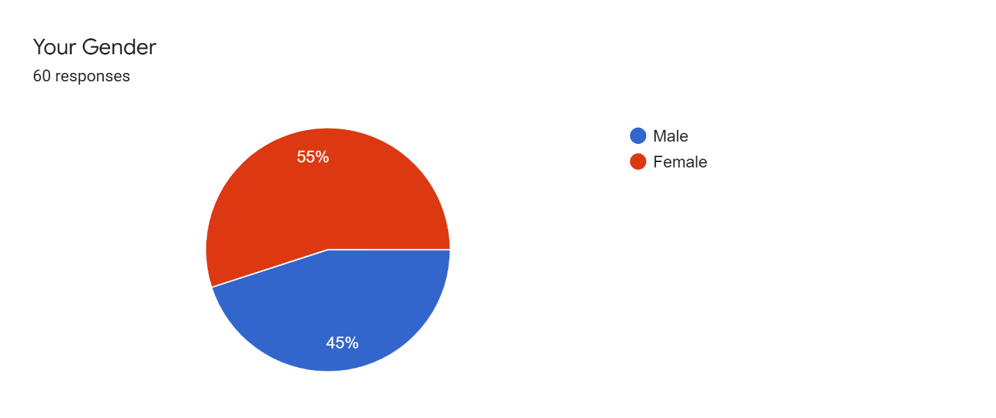

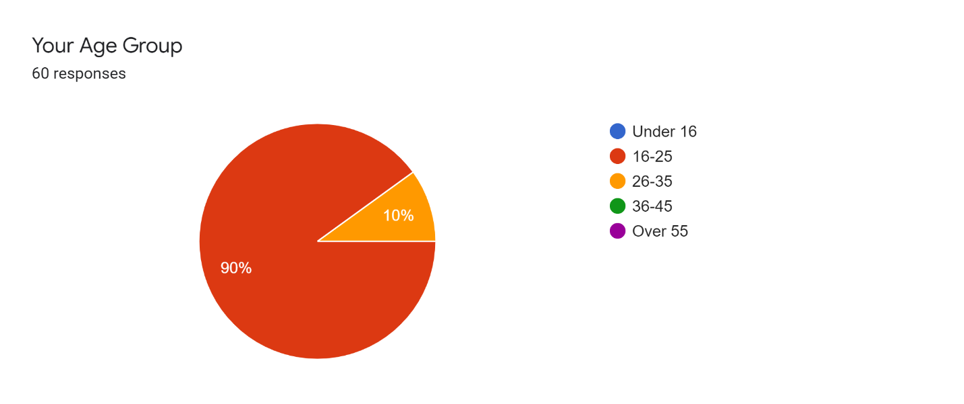

1. 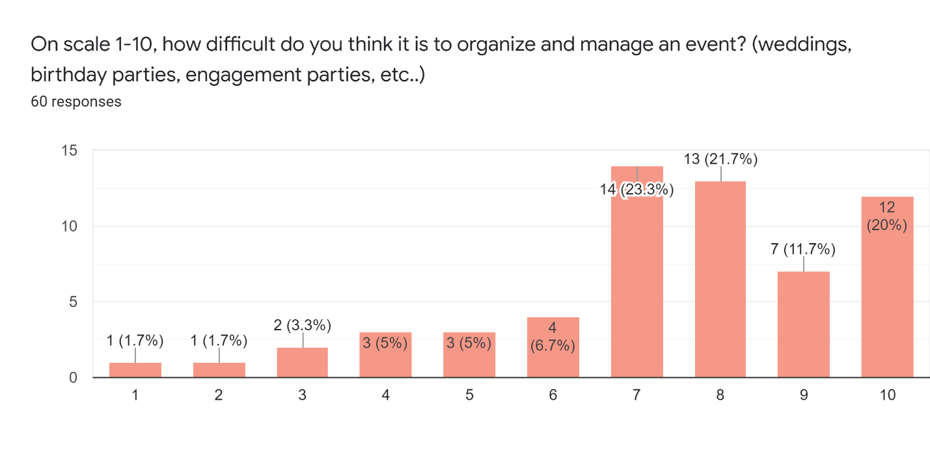

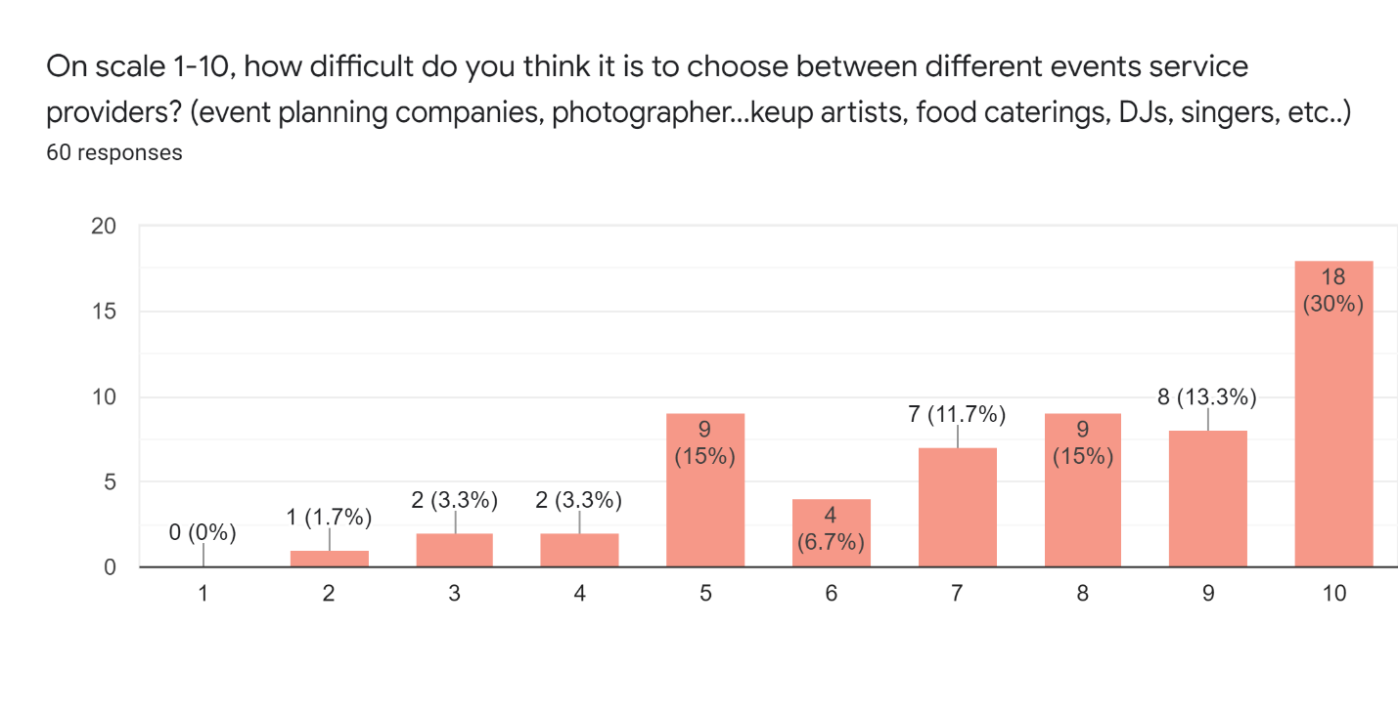

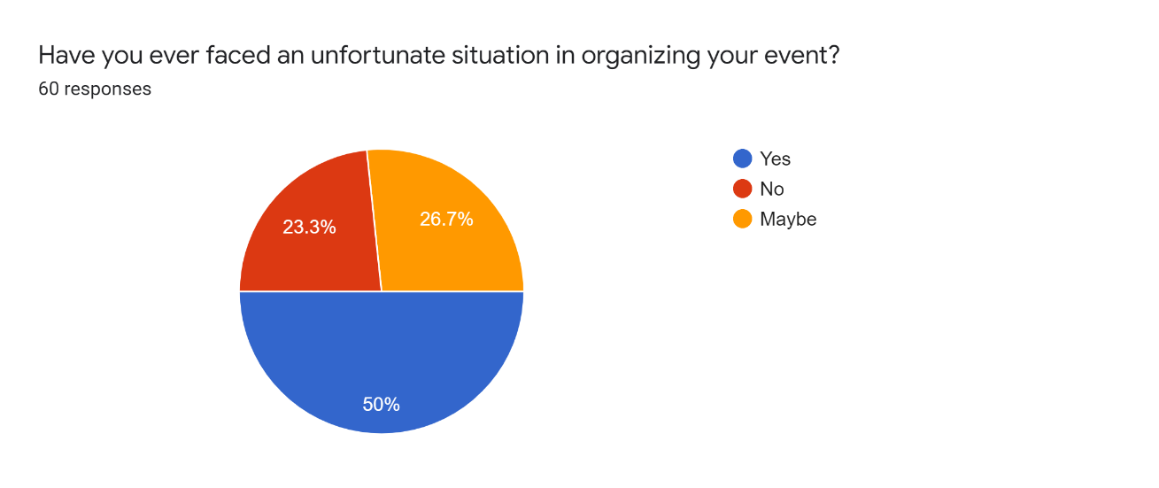

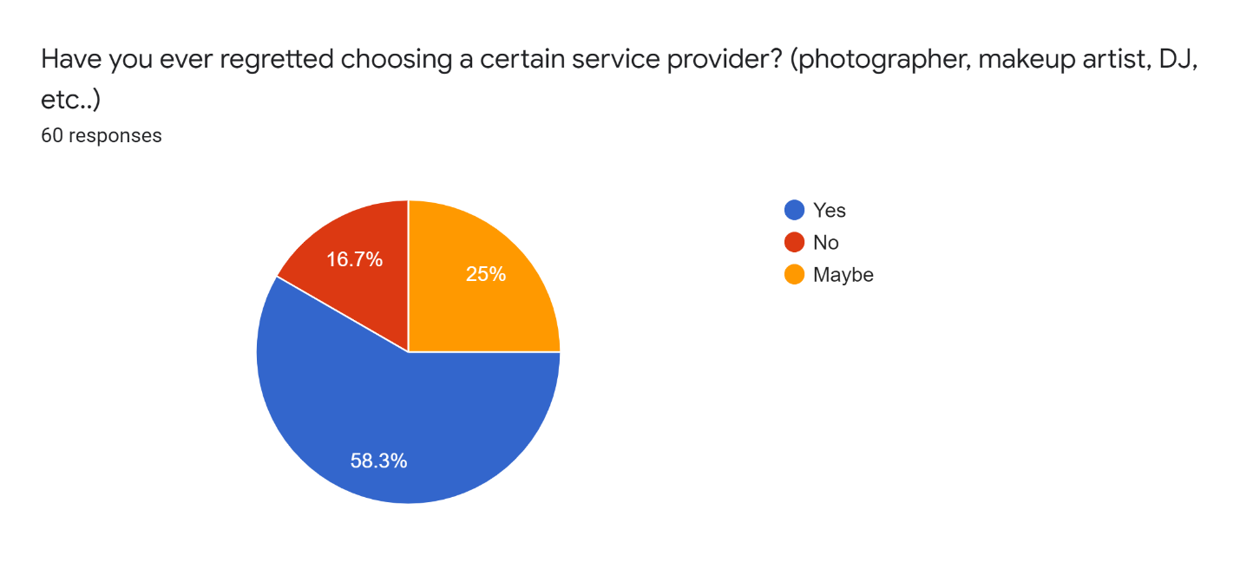

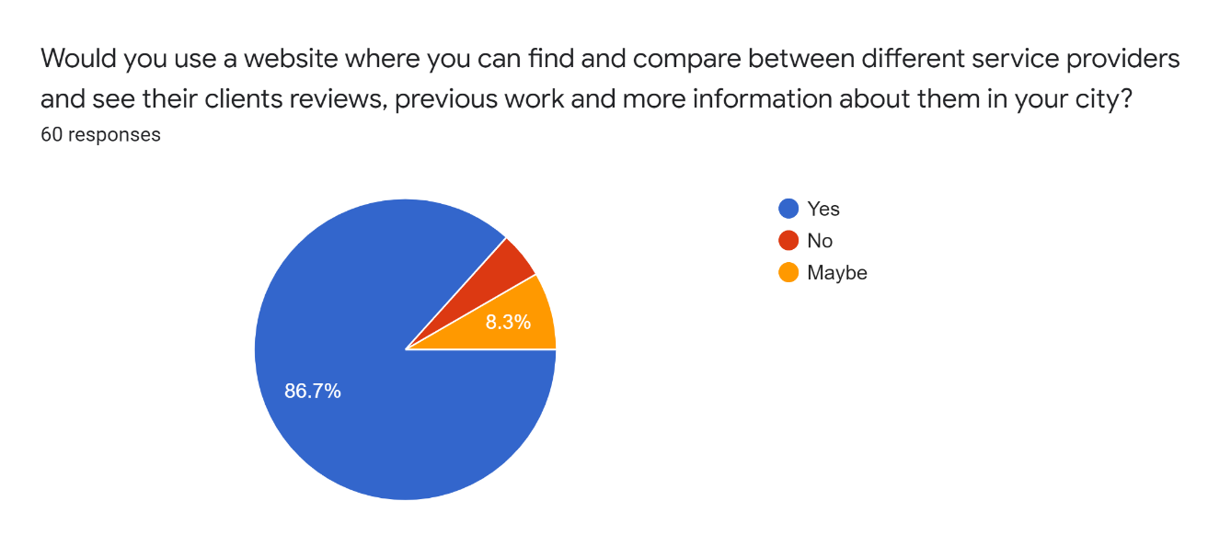

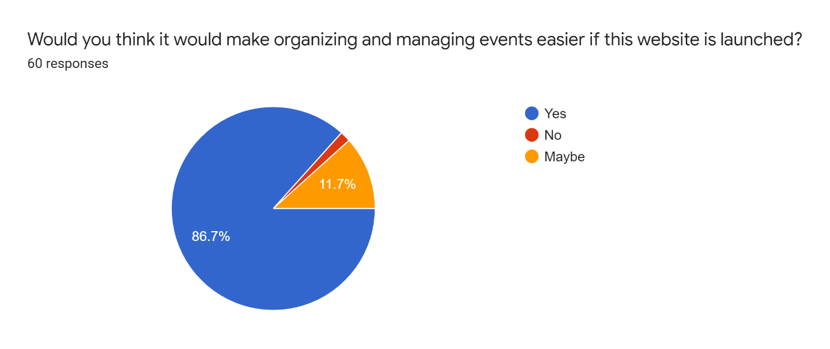

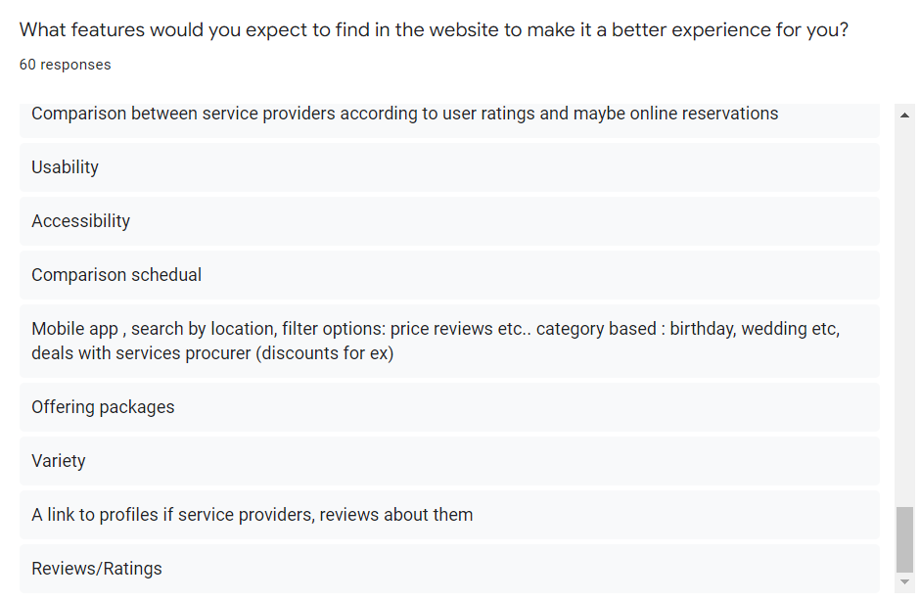

### Discussion of the survey

We gathered the survey's results once it was finished in order to analyze them. We took care to send our survey just to eligible respondents, who are primarily female and between the ages of 16 and 35.

The first question's answers revealed that 55% of respondents were female, which is advantageous for the survey's goal, as described in the preceding section.

The majority of participants chose a scale higher than five for the third and fourth questions. Which evidence suggests they have trouble planning an event, managing it, or selecting a service provider.

The purpose of the five, six, seven, and eight questions is to determine whether the project would be helpful for our consumers and to determine how eager they are for such a project. Happily, the results confirmed our expectations: 50% of our participants encountered unfortunate circumstances during their events. This could have been due to their selection of unsuitable or unprofessional service providers for their events or to their inability to properly compare and review feedback on their chosen service providers. 58 percent of attendees admit that they had second thoughts about the service provider they had selected for their event. 86 percent of the participants agree they would use our website to plan and manage events, and the same number agree that once our project is finished, the website would make planning and managing events much simpler.

In the final question, we want to give our customers a chance to share their opinions and work with us to improve the project's convenience in resolving the issue. Many ideas and recommendations for features to include in our website were sent to us.

Some of the responses we got were:

* “Comparisons with photos, experiences and people's review”
* “To be succinct, interesting and up to date.”
* “Your site must look great and work well on any platform.”
* “The site must work quickly, correctly and as expected.”
* “real client reviews, and real pictures of previous work for each service is a necessity so i can consider the website my only trusted go to when it comes to choosing”
* “Timing, price, reviews, style, realistic photos”
* “Details for everything”
* “Online payment”
* “Well organized, multiple comparison options, a design that attracts the attention.”
* “Description of the service, prices and packages, feedback of users, some photos of their previous work”
* “Maybe videos present its previous organizing”
* “1- number of events they arranged 2- price of each service they provide to save time of asking them 3- what things they will be exactly responsible of in the event .. if they will arrange the event totally or partially 4- types of events they can arrange (weddings only or others too)”
* “A website that would include everything I need to know when organizing an event, from the place to the decorations”
* “360 view of the finished product so that i could imagine the final service i am gonna get precisely”
* “To has a good interface as if everything organized this will be one of the most important things to do and this will help the website to grow faster”
* “Mobile app , search by location, filter options: price reviews etc.. category based : birthday, wedding etc, deals with services procurer (discounts for ex)”
* “A link to profiles if service providers, reviews about them”
* “Usability”
* “Accessibility”
* “Reviews/Ratings”
* “The option to compare services side by side to see which provider is better in which aspect espcially when providers have similar ratings”
* “Comparing between different makeup artists/planners by reviews Filtering the choices based on money if there is a budget, or anything relevant”
* “Recommended and trusted service providers”

Survey form: https://forms.gle/jJMMCStVYA85jLQh6

## Product Features

**Features for customers**

* Sign up to a free account
* Login into their account after signing up
* Choose a category to browse
* View all vendors in each category
* Use the live chat to answer specific questions
* Write a review about the vendor
* Report a vendor
* Compare between two or more vendor

**Features for vendors**

* Sign up to create an account
* Add listing and wait for acceptance
* View number of accounts viewed her/his profile
* Choose subscription plan
* Manage subscription
* Cancel subscription
* Update her/his information

# Project Requirements

## Requirements Gathering

### Functional Requirements

**Users:**

1. Users will be able to choose to register as a vendor or as a user.

* Users can sign up for a new account
* Enter a valid name
* Enter a valid email address
* Enter a valid password
* Register account
* Users information will be stored in the database
* User will be able to deactivate and delete his account

1. Users can login into the system

* User is required to enter a valid username
* User is required to enter a valid password

1. Users can browse for vendors

* Users will be able to browser on (Photographers, Caterings, Makeup Artists, Event Planners, DJs)
* Users will be able to sort the vendors according to their choice.
* Users will be able to sort the vendors by (Most Reviewed, Most Viewed, Highest Rated)

1. Each user will have a profile

* Users will be able to modify their profile information.
* Users will be able to view their written reviews.

1. Users will be able to send and receive messages from vendors.

* Users can check for new messages in their profile dashboard.

1. User will be able to chat with an admin whowill answer specific questions.

**Vendors:**

1. Vendors can register for a new account

* Vendor is required to enter a valid name
* Vendor is required to enter a valid password
* Vendor is required to enter a valid email
* Vendor is required to enter appropriate information to register
* Vendor will be able to remove or delete his account

1. Vendors can login to their account

* Vendor is required to enter a valid username
* Vendor is required to enter a valid password

1. Vendors can request to list their business

* Vendors will be required to enter valid information (Title, city , phone number etc…)
* Vendors request will be submitted to the system and admins will be notified once the request is submitted

1. Vendors will receive approval/Disapproval email

* Admins will study the request and vendors will be notified with their response

1. Vendors can preview their profile

* Vendors will be able to modify their profile and add addition information if required

**Admins:**

1. Admins will be notified once a vendor request is submitted

* Admins can preview the request
* Admins will be able to approve/disapprove vendor request

1. Admins will be notified once a feedback or a complaint is submitted

* Admins will be able preview the feedback or complaint and contact the user is if required

1. Have access to delete / block accounts

* Admins will be able to delete inappropriate comments or reviews if found.

### Non-Functional Requirements

1. User-Friendly and easy to use interface
2. Performance requirements

* the website loading time must be as fast as possible

1. Usability

* The website language is English which is suitable for most users

1. Availability

* Users will be able to access to the website from different platforms such as laptops, tablets, computer and phones

1. Reliability:

* The system should be able to handle a large number of users launching the system at the same time.

# Project Diagrams

## Structural Diagrams

### Entity Relationship Diagram

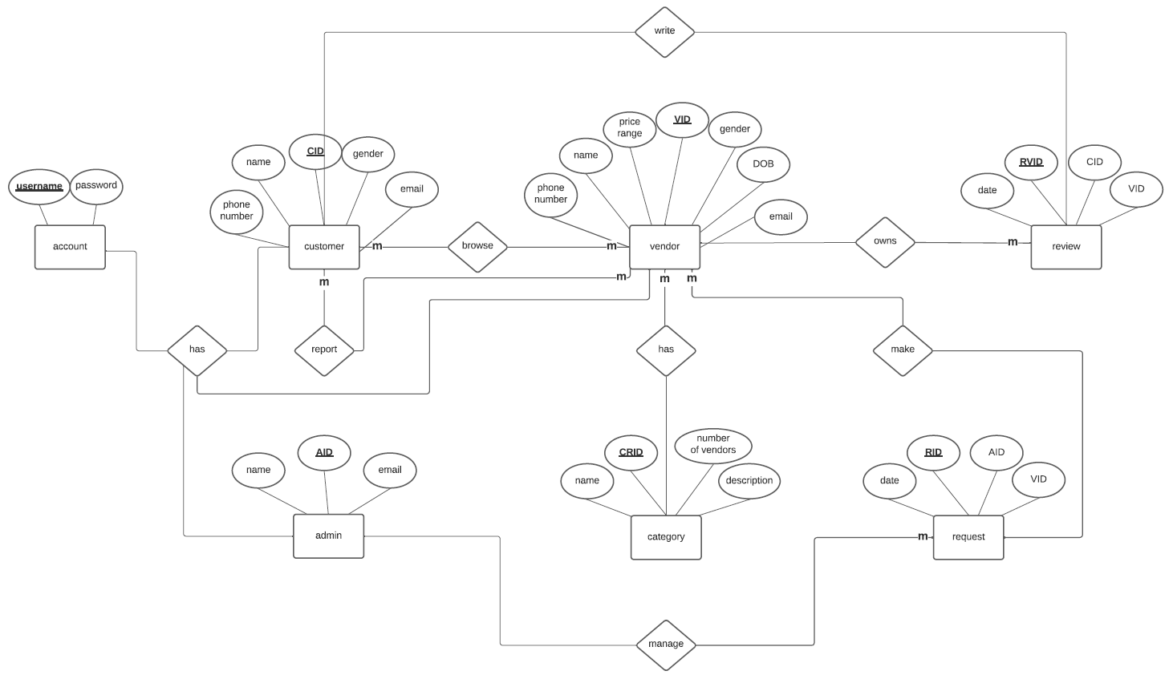

Figure "ERD"

## Behavioral Diagrams

### Use case Diagram

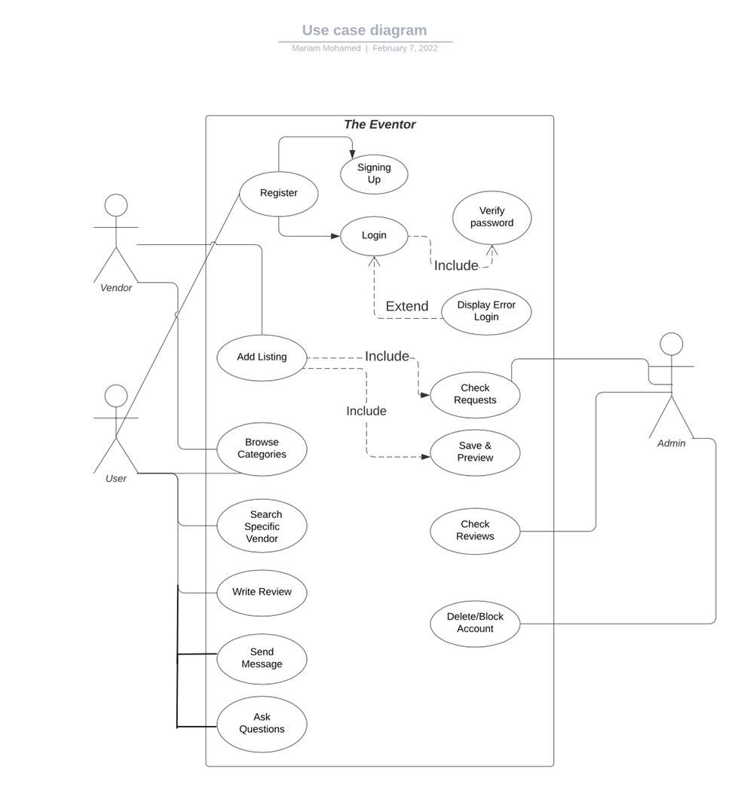

Figure "Use Case"

### State Chart Diagram

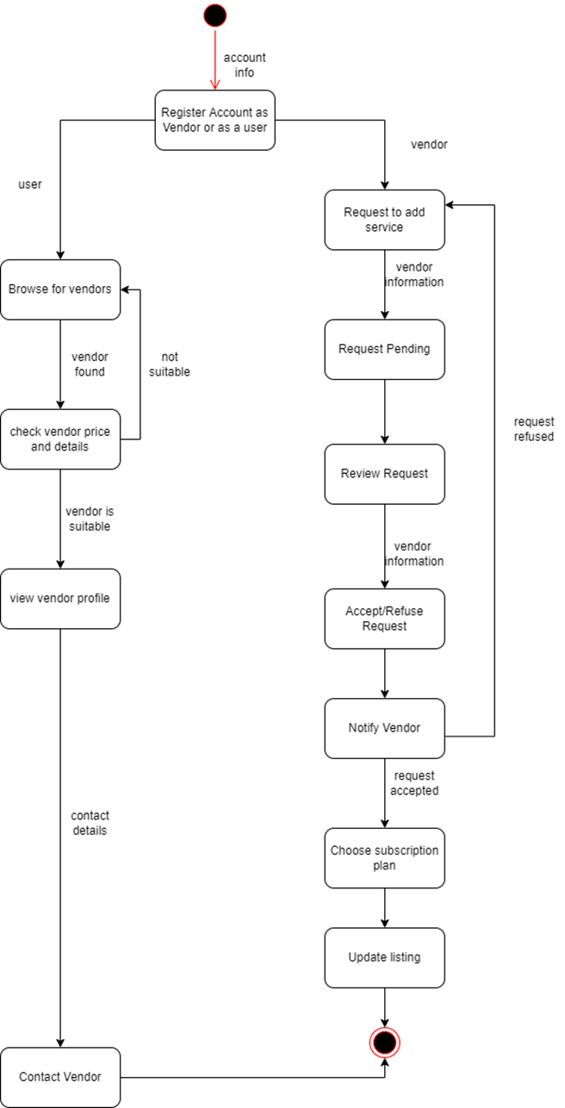

Figure "State Chart"

### Workflow Diagram

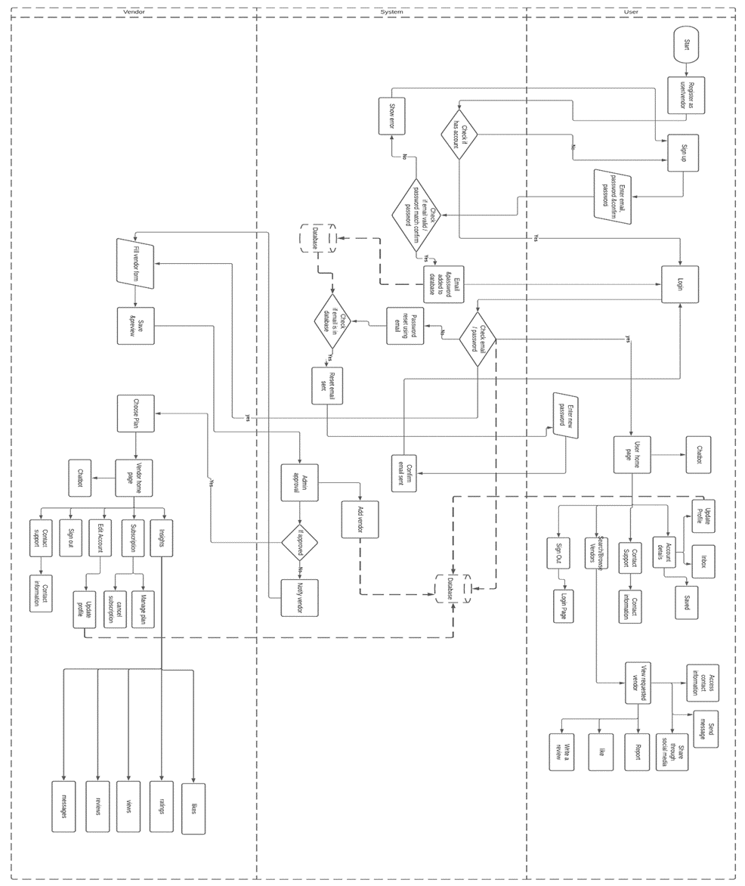

Figure "Workflow"

### Activity Diagrams

#### Registration Diagram

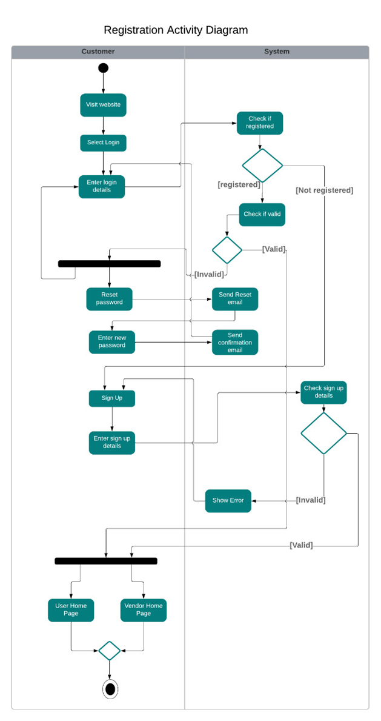

Figure "Registration Activity"

#### D:\AAST\Term 7\Graduation Project\New folder\Activity 1.jpegReport Vendor Activity Diagram

Figure "Report Vendor Activity"

#### D:\AAST\Term 7\Graduation Project\New folder\Activity 3 .jpegWrite Review Activity Diagram

Figure "Write Review"

#### D:\AAST\Term 7\Graduation Project\New folder\Activity 4 .jpegSearch for vendor activity Diagram

Figure "Search for Vendor"

#### D:\AAST\Term 7\Graduation Project\New folder\Activity 5 .jpegMessaging system activity Diagram

Figure "Messaging system"

#### D:\AAST\Term 7\Graduation Project\New folder\Activity 6 .jpegAdding Vendor Activity Diagram

Figure "Adding Vendor"

### Sequence Diagrams:

#### Registration Sequence Diagram

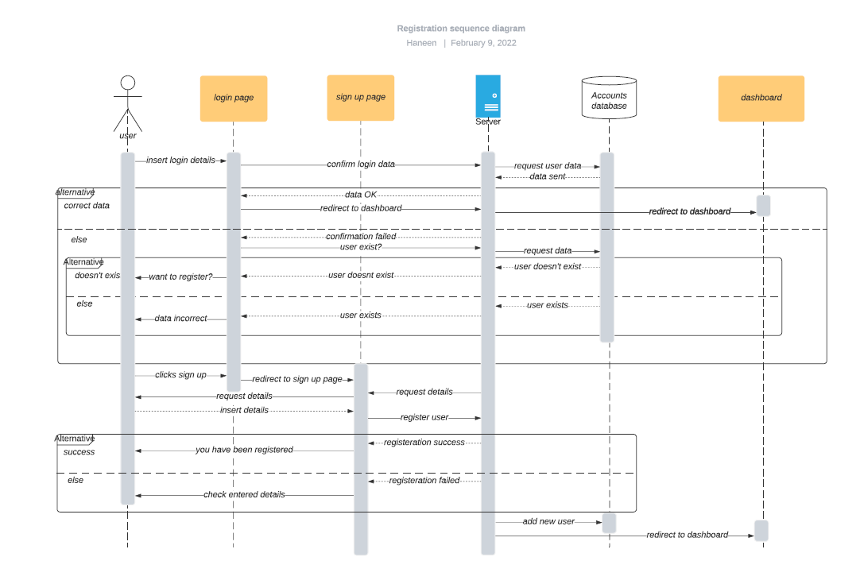

Figure "Registration Sequence"

#### Adding Vendor Sequence Diagram

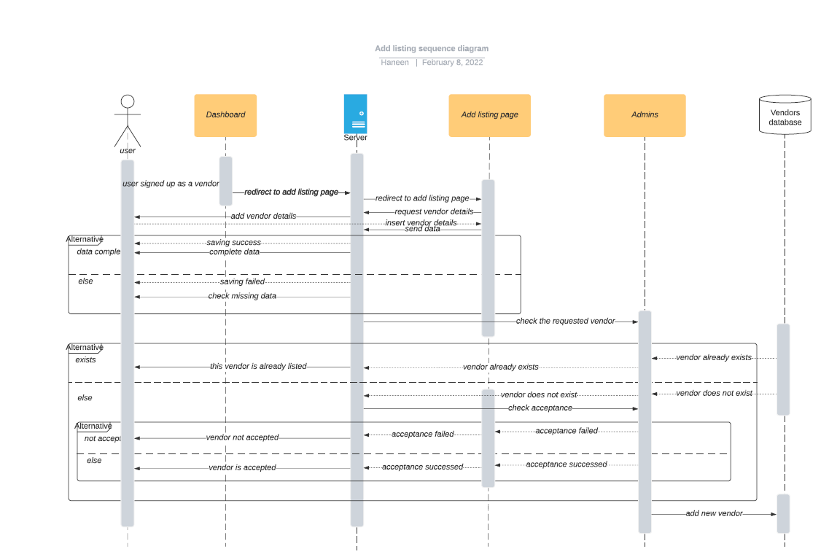

Figure "Adding Vendor Sequence"

#### Browsing for Vendors Sequence Diagram

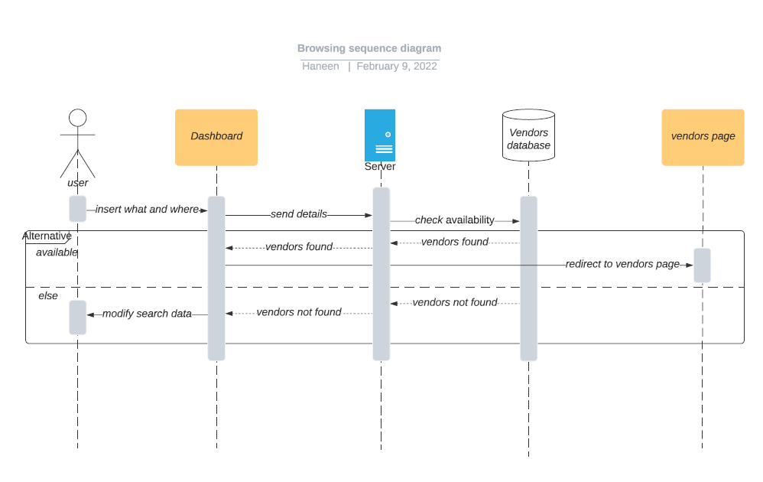

Figure "Searching for Vendors Sequence"

#### Reporting Vendors Sequence Diagram

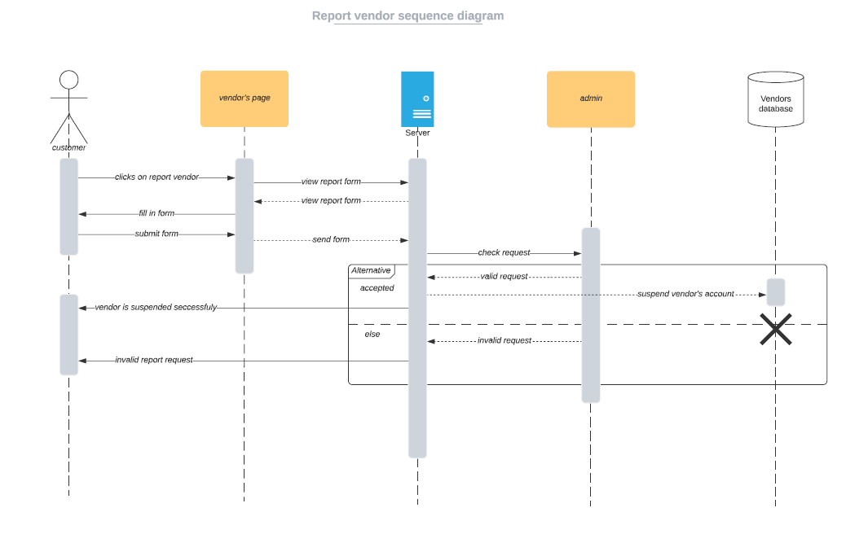

Figure "Report Vendor Sequence"

#### Writing Review Sequence Diagram

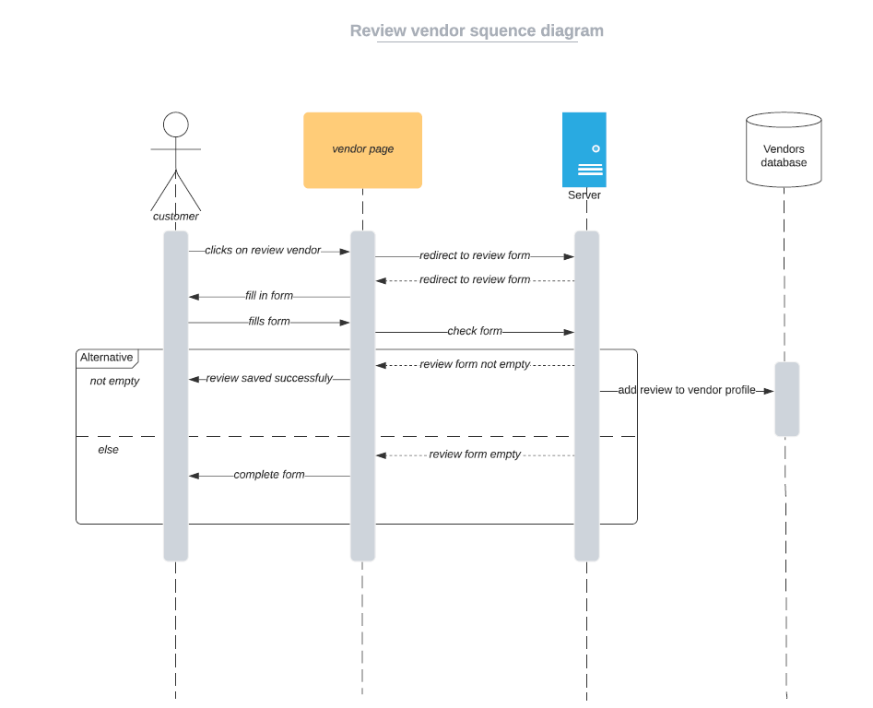

Figure "Writing Review Sequence"

# Project Implementation

## Implementation Tools

in this section, we will be discussing the implementation tools we used to complete our project. We will be discussing the reasons of choosing that tool, its advantages and disadvantages.

### Laravel:

* Laravel is a free, open source PHP web framework
* Laraval provides us with commonly used functions or APIs instead of hard coding every line, for example, laravel provides functions for routing and authentication, which makes developing our web application and handling the requests easier and more efficient.
* Laravel incorporates highly security measures to prevent hacking and injecting harmful code into the web application.
* Laravel follows the MVC architecture pattern.

### MVC Architecture Pattern:

* MVC is an acronym for Model, View and Controller.
* MVC architecture pattern is commonly used lately in web and mobile applications
* MVC is one of the most frequently used industry-standard web development framework to create scalable and extensible projects.
* MVC architecture pattern separates the application into three main logical components: the model, view and controller.

**Model:** represents the data that is being transferred between the View and Controller. For example from our project, the customer object will retrieve the customer information from the database when the customer logs in, manipulate it and update it data back to the database or use it to render data.

**View:** represents all the user interface of the application (html, CSS, JS), in our project the view represents all the visible web pages.

**Controller:** acts as interface between Model and View components to process and handle requests. The primary responsibility of the controller is to handle the events triggered by the user input. The controller contacts the model for reading/updating the data then sends the new information to View component to be shown to the user.

### HTTP requests handler

Along with the MVC architecture pattern, we used HTTP requests handler.

The HTTP request handler is part of the controller component.



Figure "HTTP request handler"

How it works?

1. The HTTP requests handler works when the user interacts with the browser which means the users triggers an event, the browser then sends an HTTP request to the web-server.
2. We have created a router folder which handles the HTTP requests or events towards the function in the controller that handles them.
3. The router then receives the HTTP request from the browser and directs it to the controller.
4. The controller interacts with model to modify or read the data from the database.
5. The new information is passed to the view component which changes its state and sends it back to the browser for the user to see.

### Redis Cache

Redis cache is an open source caching tool and of the most popular caching tools used in web applications recently.

What is caching?

Caching is a temporary storage mechanism that allows websites to load information faster. Instead of accessing the database directly, the website will access the cached version and pull the necessary information from the server memory.

Redis Cache is used in our web application to speed up website pages load time for users as we understood that performance and loading time is quite important for many users.

Redis cache speeds up the performance by temporarily storing retrieved data and information during the first visit of a user, this way then next time the user reloads the website or revisits a certain page the information can be loaded much faster from the temporary storage instead of having to access the database directly.

Redis cache works by assigning the original database query as the key and then resulting data as the value. Now, the Redis system can access the resulting database call by using the key which it has stored in its built-in temporary memory.

### Bootstrap 5

* Bootstrap is a free, open-source CSS front-end framework.
* Bootstrap 5 is the newest version of Bootstrap
* The most popular HTML, CSS, and JavaScript framework for creating responsive, mobile-first websites.
* Supports all major web browsers.

**Why we will use this tool?**

1. Simplifies the development of web pages by providing many design choices of colors, size, font and layouts.
2. Provides basic style definitions for all HTML elements.
3. To take advantage of CSS classes defined in bootstrap to further customize the appearance of their contents. Example: light and dark themes.
4. Bootstrap comes with several Javascript components in the form of JQuery plugins, which contains user interface elements such as dialog boxes, tooltips and carousels.

### JQuery

* jQuery is a fast, small, and feature-rich JavaScript library. It makes things like HTML document traversal and manipulation, event handling and animation much simpler with an easy-to-use API that works across a multitude of browsers. With a combination of versatility and extensibility.
* Free open-source software.
* As of May 2019, jQuery is used by 73% of the 10 million most popular websites.
* Web analysis indicates that it is the most widely deployed JavaScript library by a large margin, having at least 3 to 4 times more usage than any other JavaScript library

**Why we will use this tool?**

* Provides several advanced and compact selectors than CSS ones.
* Makes it easier to navigate a document or web pages.
* Makes it easier to select elements, create animations and handle events
* Allows us to create a powerful dynamic web pages.
* Provides simple syntax for adding events handlers using Javascript rather than using HTML event attributes to call Javascript functions
* Promotes clarity of the source code.
* Handles the cross-browser inconsistencies and provides consistent interface that works across different browsers

### MySQL database

* MySQL is a very popular open-source RDBMS which is used by most of the major tech companies such as Facebook, Google, Twitter and Adobe.
* It is widely used in web development because it gives high performance, it is secure, flexible and reliable.
* MySQL supports large databases, up to 50 million rows or more in a table.
* MySQL can run on Linux, Windows, OSX and FreeBSD and Solaris.

### Tawk

Tawk is a free software used in our project for live chat. Tawk offers a easy and a reliable way to communicate with our customer. The live chat will be used by customers if they have any inquiries or questions or if they would like to have assistance during their visit on the website.

Tawk is implemented in our project by adding a small javascript script into our code.

Tawk offers us several functions that would enhance the communication between us and our customers.

From the tawk dashboard, we can do the following:

* Monitor customer activity and discover which page our visitors are on in real time and how often each page is visited by the users.
* Add team members as admins and discover which team member responds to customers inquiries
* Assign conversations to a certain team member so the work can be equally distributed
* Receive messages from live chats and start conversation with users.

The figures below shows a snipped from the software dashboard to illustrate how it works:

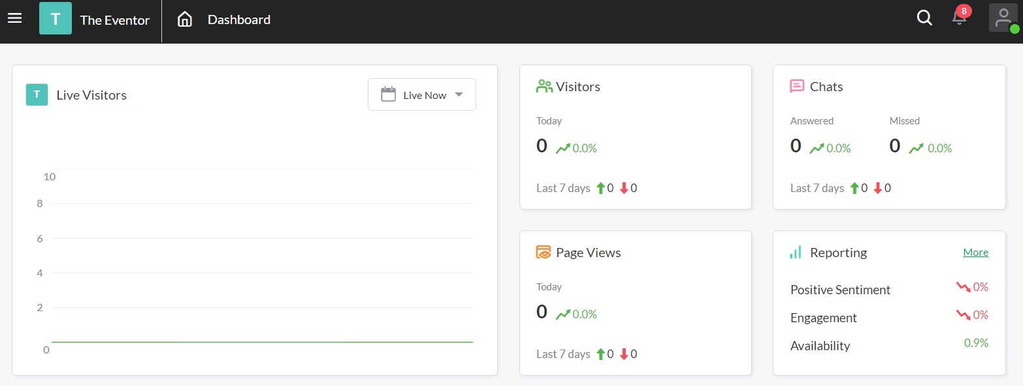

Figure "Tawk dashboard"

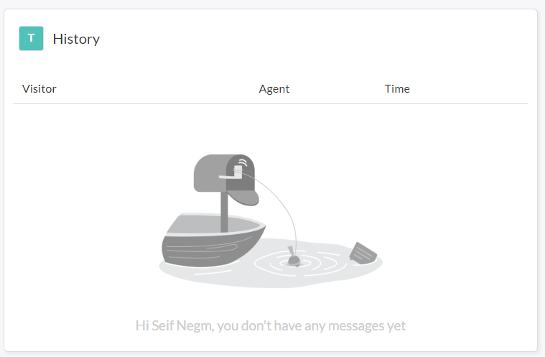

Figure "Tawk dashboard 2"

# Project Testing

## Test Plan

### Introduction

This document purpose is to describe our test plan, including our testing strategy , objectives , schedule estimation , deliverable and resources required to perform the testing plan for our project

### Business Background

This project is about a website that helps users to find vendors and service providers to plan any event

### Test Objectives:

Determine the effort needed to validate the quality to validate the quality of the application under test.

Ensure system functionalities and quality attributes are being achieved.

### Scope

In this part, we will identify the components of the system that needs to be test.

***In scope***

* Functional Testing
* Database Testing
* System usability
* System availability
* System performance

***Exclusions***

No exclusions or out of scope for this project.

### Test types to implement

Testing type is a standard procedure that gives an expected test outcome.

Testing type objective is to detect any bugs or failures early before releasing the system.

In this project we will be using the following test types:

**Unit testing:** test the smallest piece of verifiable software in the system

**Integration testing:** testing the system as a whole when the website in integrate with the database.

### Risks & Possible issues

|  |  |
| --- | --- |
| Risk | Mitigation |
| Team members lack the required skills for website testing | Take a testing course and train team members |
| Project schedule is too tight and no time enough for testing | set test priorities for each activity |
| A lack of cooperation negatively affects your employees’ productivity | Encourage each team member in his task, and inspire them to greater efforts. |
| Host server goes down | Buy alternative host server as a backup plan |
| Database erased or gets deleted | Backup database daily |
| External Malicious attacks or DDOS attempts | Implement a security plan to prevent external malicious attacks |

### Resources

**Hardware Resources:**

* Computers
* Server for database

**Manpower Resources:**

* At least three team members

**Software Resources:**

* Internet
* Database software
* Web browser application

### Features to be tested

|  |  |
| --- | --- |
| **Module Name** | **Description** |
| Registration | Users and vendors can register an account |
| Login | Users can login to their account using their saved password and emails from database |
| Browse for vendors | Users can browse for vendors, listing vendors are shown in a page |
| Sorting of vendors | Users can sort vendors according to their price, reviews |
| Massaging system | Massaging system between users and vendors |
| Live chat | An admin who can chat with users using a live chat software. |
| Add listing | Listing of vendors into the website |
| Notification system | Notifications when a user receives a message |
| Reviewing system | Users can write reviews for different vendors |
| Deleting/blocking accounts | Admins have the ability to delete or block accounts |
| System Performance | - |
| UI usability | - |
| System Availability | - |

### Testing Criteria

**Suspension Criteria:**

If the testing of the system reports that more than 60% of the features failed, the testing will be suspended until the development team fixed the functions.

**Exit Criteria:**

The exit criteria donates that the testing of the system is successful.

The testing should be 100% successful in order to release the project.

## Test Cases:

Test cases define how to test a system, software or an application. A test case is a singular set of actions or instructions for a tester to perform that validates a specific aspect of a product or application functionality. If the test fails, the result might be a software defect that the organization can triage.

In our project, we performed a number of test cases and made sure all test cases results are successful and for each test case, we used a fixed template.

Below are some of the test cases we performed,

Login function test case:

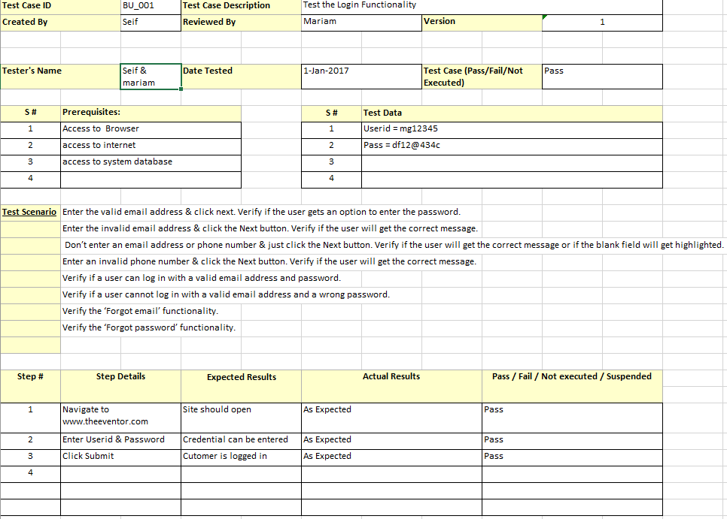

Figure "Login Test Case"

Sign up function test case:

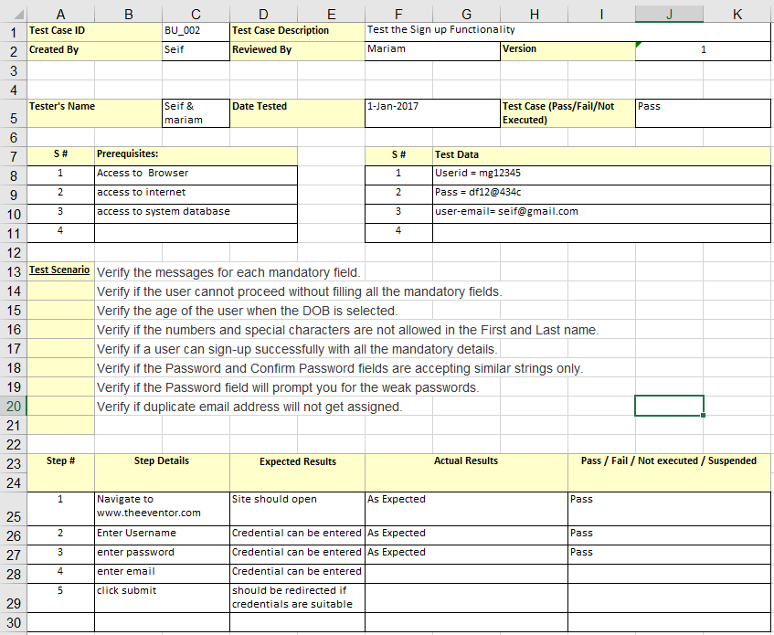

Figure "Sign up test case"

Search & Sorting test case:

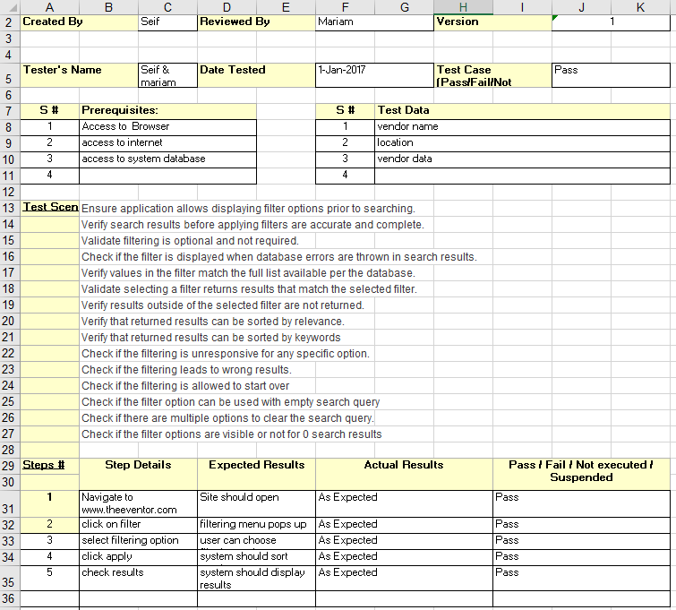

Figure "Search & Sorting test case"

Reviewing system test case:

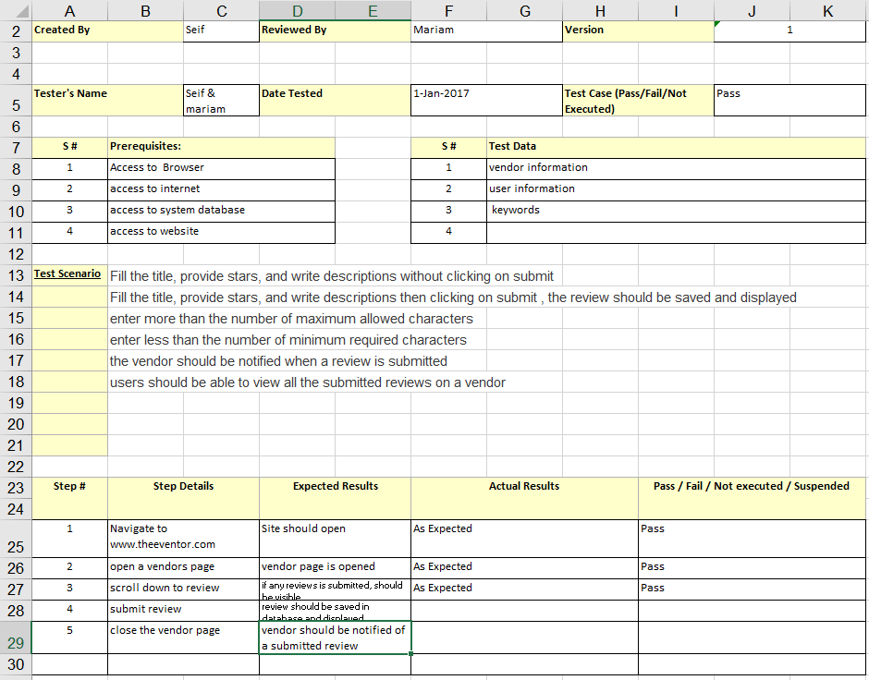

Figure "Reviewing system test case"

# Summary & Conclusions

## Summary of the Work

In the last chapter of this documentation, we are glad to present the Eventor website.

We will also be grateful and hopeful that you would give us your feedback or any suggestions that would improve our project.

## Future Plans

We believe the improvement and developing our project will never stop, we came across some future plans we would implement. We believe the following plans are not suited for a start-up project and would not be successful for the initiation phase.

* Adding more plans to our existing subscription plans
* Add a calculator function where users can calculate the average cost for their event
* Add 360-view feature of vendors’ products or venues so the customer can get a precise view of the product or venue. The function must be working efficiently on all different platforms.
* Creating a mobile application with high usability.
* Singing deals with vendors to get a percentage for every customer they get through our website
* Globalize our website through the world and different cities and not just in Egypt.

## Challenges & Problems Faced

As we worked throughout the project, we faced several challenges and problems that were not expected. We can summarize most of the challenges as the following:

* Choosing a suitable and professional domain for our website.
* Choosing the right host server as the options were various.
* Paying for the host server.
* Choosing and learning new tools to create the website
* Time management between our studies for our last semester and working on the project.
* Finding the right time for project meetings.
* Disagreements between team members which sometimes lead to tension.
* Difficulty of gaining customer trust

However, despite the high number of challenges we faced, we managed to solve each challenge and come to a complete solution for each challenge as a team which eventually lead to the completion of the project.

## Lesson learned & Suggestions for future work

As we managed to get through the challenges, we faced, we learned several lessons and we will be sure to implement them our future projects

We can summarize the lessons learned in the following:

* Ensure to make a good plan before the implementation phase
* Ensure to make the right choice of the implementation tools
* Always make sure to study the consumer point of view and see his perspective of the problem
* Always make sure to choose a team leader
* Always make sure to assign the right tasks to the right person
* Always make sure to ask for advices and suggestions from experts and more experienced individuals.
* Always make sure to listen to experts advices.

# References:

1. Gantt.com. 2022. *Gantt.com*. [online] Available at: <https://www.gantt.com/> [February 2022].
2. Tutorialspoint.com. 2022. *Requirement Gathering Techniques*. [online] Available at: <https://www.tutorialspoint.com/business_analysis/business_analysis_requirement_gathering_techniques.htm>
3. Utm.mx. 2022. *Guideline: Requirements Gathering Techniques*. [online] Available at: <https://www.utm.mx/~caff/doc/OpenUPWeb/openup/guidances/guidelines/req_gathering_techniques_8CB8E44C.html>
4. Lucidchart. 2022. *Intelligent Diagramming | Lucidchart*. [online] Available at: <https://www.lucidchart.com/pages/> [Accessed 26 February 2022].
5. Guru99. 2022. *TEST PLAN: What is, How to Create (with Example)*. [online] Available at: <https://www.guru99.com/what-everybody-ought-to-know-about-test-planing.html>
6. Tutorialspoint.com. 2022. *UML - Statechart Diagrams*. [online] Available at: <https://www.tutorialspoint.com/uml/uml_statechart_diagram.htm> [Accessed 26 February 2022].
7. Monasabat, [no date]. Available from: https://monasabat.app/ [Accessed 27 October 2021]
8. Infinity Hospitality, 02 June 2016. [Online] Available from: https://infinityhospitalitygroup.com/ [Accessed 25 October 2021]
9. Infinity Hospitality Reviews, [no date]. [Online]. Available from: https://www.weddingwire.com/reviews/infinity-hospitality/44f3a1df4e7c56f8.html [Accessed 25 October 2021]
10. Wedding Wire, [no date]. [Online]. Available from: https://www.weddingwire.com/ [Accessed 27 October 2021]
11. Wedding Wire Reviews, [no date]. [Online]. Available from: https://www.trustpilot.com/review/weddingwire.com [Accessed 27 October 2021]
12. J. Allen. 10 Great Wedding Apps to Help You Plan Your Big Day, 24 May 2017. [Online] Available from: <https://www.pastemagazine.com/tech/apps/10-great-wedding-apps-to-help-you-plan-your-big-day/> [Accessed 25 October 2021]
13. Weddbook, [no date]. [Online]. Available from: https://weddbook.com/ [Accessed 28 October 2021]
14. Bootstrap (front-end framework), 09 October 2021. [Online]. Available from: https://en.wikipedia.org/wiki/Bootstrap_(front-end_framework) [Accessed 5 January 2022]
15. The Bootstrap Blog, [no date]. [Online]. Available from: https://blog.getbootstrap.com/ [Accessed 5 January 2022]
16. jQuery, [no date]. [Online]. Available from: https://en.wikipedia.org/wiki/JQuery [Accessed 5 January 2022]
17. A. Upadhyay. Top 7 Database You Must Know For Software Development Projects, 06 January 2020. [Online] Available from: https://www.geeksforgeeks.org/top-7-database-you-must-know-for-software-development-projects/ [Accessed 5 January 2022]
18. K. Goyal. How to Make a Chatbot in Python Step By Step[Python Chatterbox Guide], 27 July 2020. [Online] Available from: https://www.upgrad.com/blog/how-to-make-chatbot-in-python/ [Accessed 5 January 2022]
19. SurveyMonkey. 2022. *Survey Best Practices & Design Guidelines | SurveyMonkey*. [online] Available at: <https://www.surveymonkey.com/mp/survey-guidelines/> [Accessed 3 July 2022].
20. Laravel.com. 2022. *Laravel - The PHP Framework For Web Artisans*. [online] Available at: <https://laravel.com/> [Accessed 4 July 2022].
21. Afteracademy.com. 2022. *MVC Architecture in Web Applications*. [online] Available at: <https://afteracademy.com/blog/mvc-architecture-in-web-applications> [Accessed 4 July 2022].
22. tawk.to. 2022. *100% FREE Live Chat Software, Ticketing & Knowledge Base! - www.tawk.to*. [online] Available at: <https://www.tawk.to/> [Accessed 4 July 2022].
23. 2022. [online] Available at: <https://redis.io/> [Accessed 4 July 2022].
24. Nexcess. 2022. *What is Redis Cache? Redis Cache Explained Simply [2022] | Nexcess*. [online] Available at: <https://www.nexcess.net/blog/what-is-redis-cache/> [Accessed 4 July 2022].



**Arab Academy for Science, Technology, and Maritime Transport**

**COLLEGE OF COMPUTING AND INFORMATION TECHNOLOGY**

Academic Year: 2021/2022 Semester: February 2022

|  |  |  |
| --- | --- | --- |
| **Project Title** | ***The Eventor*** | |
| **Supervisor(s)** | **Dr. Saleh Mesbah – Dr. Walid Rabie** | |
| **Team members:** | **Names**  **Seif El-Deen Amr Hussein Negm**  **Mariam Mohamed Abdelhamid**  **Haneen Mohamed**  **Nadeen Ahmed** | **RegistrationNumbers**  **18100683**  **18102057**  **18100568**  **18100359** |
| **Project Deliverables** | *Website for organizing & managing events* | |
| **Team Organization** | *Seif El-Deen Negm: Project Documentation, Diagrams, Identifying required tools, Identifying Functional & Non-Functional requirements, Test Plan, Test Cases.*  *Mariam Mohamed: Project Mini-Movie, Documentation, Implementation*  *Haneen Mohamed: Project Documentation , Identifying Database attributes, entities & tables*  *Nadeen Ahmed: Project Documentation, Implementation.*  *Each team member contributed to the project in the best way he/she can, we acted as one team and most of the tasks were equally distributed equally between the team members.* | |
| **Ethical Considerations** | *No Ethical Considerations exists* | |
| **Social Impact** | *We believe our project will have positive social effects on people and communities, as our main objective is to make events planning and management easier and less stressful. Where you can organize a full event from one place. Events helps to gather a large number of people in one place to celebrate a certain situation in their lives which we would be gladly helping in organizing those events.* | |
| **Professional Responsibility** | *We, the Eventor project team members, considered the professional responsivities in a serious matter. As a result, we made sure our project complies and obeys the Egyptian laws of cybersecurity, we provide full confidentiality and secrecy for users and non-users private information and we confirm that no information or data will be shared with third-parties unless agreed.*  *We also made sure that our project complies and respects the ethics and cultures of the Egyptian society.*  *We pledge to stick and respect our professional responsibilities and to do our best to solve any issues in the near future.* | |

**Senior Project Summary Report**

|  |  |
| --- | --- |
| **Supervisor Name** | **Signature** |
| **Dr. Saleh Mesbah** |  |
| **Dr. Walid Rabie** |  |